**Welcome to Physician’s Pain and Spine Center located at**

**3227-F Sunset Boulevard, Suite 102, West Columbia, SC 29169.**

**Our office phone number is (803)724-2336 and our fax number is (803)724-2317.**

**We ask that you arrive to your appointment 30 minutes prior to your appointment time and have ALL paperwork completed or risk being rescheduled.**

**Bring your ID and insurance card to every appointment.**

We are dedicated to providing you with the best medical care and service possible. Your understanding of our policies, including our financial policy is an essential part of your care and treatment. If you have questions or concerns please ask one of the staff to assist.

## APPOINTMENTS:

If you are unable to keep your scheduled appointment, we require a 24-hour notice. The following are our fees for cancellations and no shows.

* $25.00 for cancellations less than a 24-hour notice
* $50.00 for a missed appointment
* $100.00 for a missed procedure appointment

If you call our office and are unable to speak to someone, please leave a voicemail so that the date and time of your call is documented and eliminates the risk of a cancellation fee. Three missed appointments may result in dismissal from our practice.

You will receive a pre-recorded appointment reminder, text, and E-mail once you are our patient so updating us on any changes to your contact information is important.

## FINANCIAL POLICIES:

**Patients are expected to pay his/her co-pay at the time of your visit.** If you are not prepared to pay your co-pay, you will be asked to reschedule. We accept Visa, Mastercard, Discover, American Express, money orders and cash as payment options.

## MEDICAL TREATMENT, RELEASE OF INFORMATION, AND AUTHORIZATION OF PAYMENT:

I, give consent for treatment to be rendered by the providers at Physician’s Pain and Spine, LLC. This includes my authorization to bill my insurance company as well as understanding that all payments are to be made on your behalf to Physician’s Pain and Spine, LLC. This consent also authorizes PPSC, LLC to use my health information to obtain payment from insurance companies.

**Initial Please**

Our office is contracted with various insurance companies. As a courtesy, all patient claims will be billed through their primary and secondary (if applicable) insurances. If your insurance company is not contracted with Physicians’ Pain and Spine, your claim will be filed as “Out of

Network”. We recommend that you familiarize yourself with your benefits and the responsibilities of your plan, as you are ultimately responsible.

We **DO NOT** accept Medicare/Medicaid Dual options. We are not in network with Aetna, United Health Care (commercial), Christian Care Ministries, Private Health Care Systems (PHCS) and Medcost. We **DO NOT** accept Medicaid as a Primary insurance. It is patient responsibility, for any balances after claims have been filed through insurance and your balance will be requested to be paid in full at your next appointment.

I, , understand and agree that I am responsible for any claim not covered by Medicare, insurance company or other payers. We do not offer payment plans.

If at any time you go on Hospice **YOU MUST** inform us the day you go on so we can contact the Hospice Company.

**Initial Please**

Physician’s Pain and Spine, LLC reserves the right to send accounts with balances over 60 days past due to an outside collection agency. The collection agency has the right to report the past due balances to all three credit bureaus if they fail to collect the balance on the account.

## MEDICATION POLICIES:

Medication supplies and refills are the patient responsibility. Be mindful of your due dates for refills. Any patient receiving controlled medications or narcotic pain relievers are required by law to be seen prior to receiving prescription or prescription refills. No prescriptions will be written or refilled without an office visit, **NO EXCEPTIONS**. If your insurance company requires a Prior Authorization for a medication written, this could take between 7-10 business days. If prescription or narcotics are lost or stolen (even with police report) they CAN NOT and WILL NOT be filled before due date.

As a patient you understand that you will be asked to provide a urine specimen randomly. The fee for a urine specimen in this office is the patient’s responsibility. Our practice is contracted with an outside lab contractor for our urine specimens and mouth swabs. Any non-covered amount by your insurance company is patient responsibility and all billing issues related to urine specimens or mouth swabs should be directed to the contracted lab.

I have read, understand and acknowledge the above policies of Physician’s Pain and Spine, LLC.. I have received a copy of “NOTICE of PRIVACY PRACTICES”.

Print Name: Date of Birth: Signature: Date: Revised 07/22/2021

Please **PRINT!!!** Date:

**PATIENT INFORMATION**

Last Name First Name Middle Initial Nickname/AKA

Date of Birth Social Security Number Gender

|  |  |  |  |  |  |  |
| --- | --- | --- | --- | --- | --- | --- |
| Marital Status | O Married  O Separated | | O Single  O Widowed | O Divorced O Other | O Life Partner | Language other than English |
| Race O Black- O American Indian/ O Hispanic O Asian/Pacific O White- O Other | | | | | | |
| Non-Hispanic | | Alaskan Native | |  | Islander | Non-Hispanic O Refused to Answer |
| Home Address | |  | | Apt# | City | State Zip Code |

Cell Phone Work Phone Other Phone

O Home O Fax

Email Address Employment O Active Duty Military O Employed Full-Time O Not Employed O Student Full-Time

**Status** O Self Employed O Employed Part-Time O Retired O Student Part-Time

O Disabled O Homemaker O Other

Employer Employer Phone Occupation

Pharmacy Name Pharmacy Address Pharmacy Phone

**PHYSICIAN REFERRAL INFORMATION**

Primary Care Physician Referring Physician

Address Phone Number Address Phone Number

**EMERGENCY/NEXT OF KIN CONTACT INFORMATION**

Last Name First Name Relationship to Patient

Address Apt # City State Zip Code

Cell Phone Work Phone Other Phone

O Home O Fax

**PLEASE CONTINUE TO THE BACK OF THIS PAGE TO FILL OUT INSURANCE INFORMATION.**

**RESPONSIBLE PARTY (GUARANTOR) INFORMATION**

|  |  |  |  |  |
| --- | --- | --- | --- | --- |
| Relationship to Patient | O Self | O Spouse O Parent | O Other |  |
| Last Name |  | First Name |  | Relationship to  Patient |
| Address |  | Apt # City | State | Zip Code |
| Home Phone |  | Work Phone |  | Other Phone |
|  |  |  |  | O Cell O Fax |

**INSURANCE INFORMATION**

1st Insurance Name 2nd Insurance Name

Group#: Group #:

Policy ID: Policy ID:

Policyholder Name: Policyholder Name:

Relationship to Patient: Relationship to Patient:

Policyholder DOB: Policyholder DOB:

Policyholder Employer: Policyholder Employer:

**HAVE YOU EVER SEEN A PAIN PHYSICIAN BEFORE? O YES O NO**

**IF YES, PLEASE PROVIdE THE NAME ANd CONTACT INFORMATION OF YOUR PREVIOUS PAIN PHYSICIAN:**

**SIGNATURE dATE**

**REVISEd 07/22/2021**

# New Patient Medical History

Date:

**Name**: **Date of Birth**: ( ) Male ( ) Female **Marital Status**: Single Married Separated Divorced Widowed **Any Known Drug Allergies:**

**Chief Complaint/Reason for Visit**:

**Date pain began**:

**Please CIRCLE area of complaint above.**

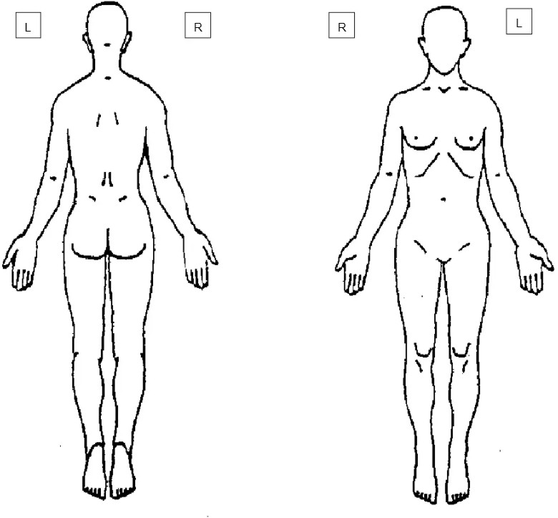

**What caused your pain**? ( ) Work Injury ( ) Auto Accident ( ) Home Injury ( ) Unknown **Is this work related? (Did you get hurt on the job?) Yes No (circle one) Is this auto related? (Were you in a car wreck?) Yes NO (circle one)**

Do you have a lawsuit on going OR pending OR are you hiring an attorney regarding this matter? ( ) Yes ( ) No

**Description of Injury**:

**Describe your pain**:

**How frequent is your pain**? ( ) Constant ( ) Intermittent ( ) Occasional ( ) Other:

**What makes your pain better**?

**What makes your pain worse**?

**Pharmacy**: **Phone** #:

**Address**:

**Past/Current Medical History**: (Check all that apply)

|  |  |  |  |  |  |  |  |
| --- | --- | --- | --- | --- | --- | --- | --- |
| **Abdominal Hernia** |  | **Bone Disease** |  | **Heart Attack under 55** |  | **Schizophrenia** |  |
| **Alcoholism** |  | **Cancer** |  | **Heart Disease** |  | **Seizure** |  |
| **Anxiety** |  | **Diabetes** |  | **High Blood Pressure** |  | **Stroke** |  |
| **Arthritis** |  | **Drug Abuse** |  | **High Cholesterol** |  | **Thyroid Disease** |  |
| **Asthma** |  | **Eczema** |  | **Osteoporosis** |  | **Ulcer** |  |
| **Bipolar** |  | **Glaucoma** |  | **Rheumatoid Arthritis** |  |  |  |

**If you have a history of cancer, what type of cancer?**

**Surgical History**: (Use an additional piece of paper if necessary)

Surgery: Date:

Surgery: Date:

Surgery: Date:

Surgery: Date:

Surgery: Date:

# FAMILY HISTORY: (Please include all immediate family information) Indicate M-Mother F-Father B-Brother S-Sister

|  |  |  |  |  |  |
| --- | --- | --- | --- | --- | --- |
| **Alcoholism** |  | **Arthritis** |  | **Asthma** |  |
| **Bipolar** |  | **Bone Disease** |  | **Diabetes** |  |
| **Drug Abuse** |  | **Eczema** |  | **Heart Attack (under 55)** |  |
| **Heart Disease** |  | **High Blood Pressure** |  | **High Cholesterol** |  |
| **Rheumatoid Arthritis** |  | **Schizophrenia** |  | **Seizures** |  |
| **Stroke** |  | **Thyroid** |  |  |  |
| **Cancer** |  | **Type of Cancer** |  |  |  |
|  |  |  |  |  |  |

**Social History**:

**Smoking status**:

Never

Former Date Quit: Current Packs per day:

**Alcohol Intake**:

None

Occasional

Moderate

Heavy # drinks per week:

**Recreational Drug Use**: Current User Drug Name: Start Date

Former User Drug Name: Quit Date

**Caffeine Intake**: None Occasional Moderate Heavy

**Exercise Level**: None Occasional Moderate Heavy

Are you **Left** Handed

**Right** handed:

Both

**Diet:** Regular Vegetarian Vegan Carbohydrate Cardiac Diabetic Gluten Free Specific

**Pain Management Before**? YES NO Pain Physician:

Relieved Pain? ( ) Yes ( ) No Where on Body?

**BRING ALL MEDICATIONS TO THIS APPOINTMENT PLEASE**

**CURRENT MEDICATIONS**

**List ALL medications that you are currently taking. Please include ALL Pain medications and as needed medications.**

Medications: Strength: Frequency: Prescribing Physician:

Medications: Strength: Frequency: Prescribing Physician:

Medications: Strength: Frequency: Prescribing Physician:

Medications: Strength: Frequency: Prescribing Physician:

Medications: Strength: Frequency: Prescribing Physician:

Medications: Strength: Frequency: Prescribing Physician:



|  |  |  |  |
| --- | --- | --- | --- |
| Date:  Patient Name: | DOB: |  | |
| (Circle answer) |  |  | |
| Family History of Substance Abuse: |  |  | |
| * Alcohol |  | Yes No | |
| * Illegal Drugs |  | Yes No | |
| * Prescription Medications   Personal History of Substance Abuse: |  | Yes No | |
| * Alcohol | Yes | | No |
| * Illegal Drugs | Yes | | No |
| * Prescription Medications | Yes | | No |
| Age (between 18-45) | Yes | | No |
| History of Preadolescent Sexual Abuse: | Yes | | No |
| Psychological Disease: |  | |  |
| * Attention Deficit Disorder | Yes | | No |
| * Obsessive Compulsive Disorder | Yes | | No |
| * Bipolar | Yes | | No |
| * Schizophrenia | Yes | | No |
| * Depression | Yes | | No |

Updated 8/18/2021



# Patient Authorization Release of Information

Name of Patient: Date of Birth:

PHYSICIAN’S PAIN AND SPINE CENTER, L.L.C. is authorized to release health information about the above patient to the entity’s names below. The purpose is to inform the patient or others in keeping with the patient’s instructions due to HIPAA.

Entity to Receive Information Description of information to be released Check each person that you approve to Check each that can be given to person receive information. on the left in this section.

Spouse Name: Medical Financial All

|  |  |  |  |  |
| --- | --- | --- | --- | --- |
| Other: |  | Medical | Financial | All |
| Other: |  | Medical | Financial | All |
| Other: |  | Medical | Financial | All |
| Other: |  | Medical | Financial | All |

Patient Information:

* I understand the disclosed information may include information and records protected by Federal Law (such as alcohol and drug treatment) and/or State Law (such as mental health, AIDS, or HIV).
* I understand that I have the right to revoke this authorization at any time and I have the right to inspect or copy the protected health information to be disclosed as described in this document. I understand that a revocation is not effective in cases where the information has already been disclosed but will be effective going forward.
* I understand that information that is disclosed as a result of this authorization may be subject to re-disclosure by the recipient and may no longer be protected by federal or state law.
* I understand that I have the right to refuse to sign this authorization and that my treatment will not be conditioned on signing. THIS AUTHORIZATION SHALL BE IN EFFECT UNTIL REVOKED BY THE PATIENT.

Signature of Patient Date

Revised 07/27/2020

3227 Sunset Blvd., Building F, Suite 102, West Columbia, SC 29169-3201 803-724-2336 (P) 803-724-2317(F)